Outdoor Burning
in Texas

Field Operations

Texas Commission on Environmental Quality

RG-049
Revised August 2008

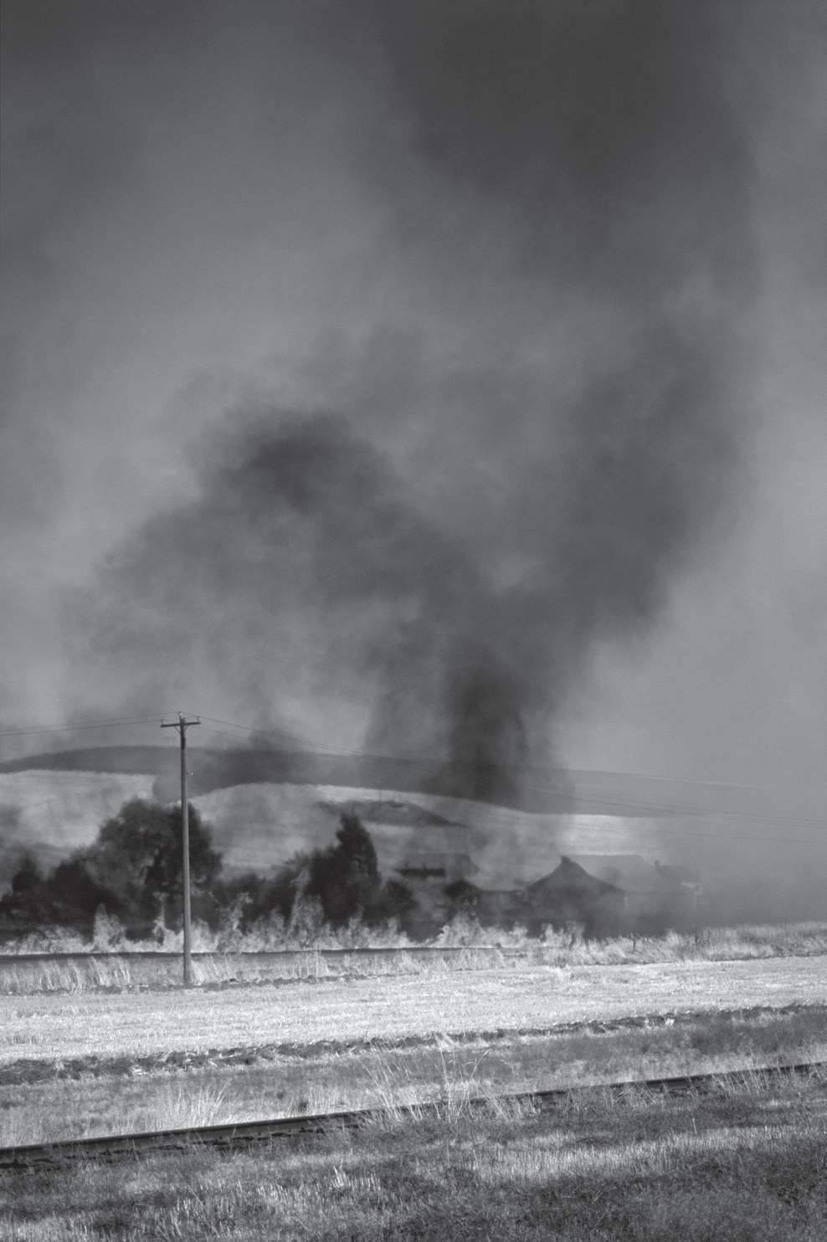Contents

Introduction 3

The Outdoor Burning Rule Explained 3
Summary of the Rule 3 Exceptions to the Prohibition 4
Firefighter Training 4

Fires for Recreation, Ceremonies, Cooking, or Warmth 4 Fires for Disposal or Land Clearing 5
Prescribed Burns 8

Pipeline Breaks and Oil Spills 8 Other Situations 8
General Requirements for Burning 9 Practical Alternatives to Burning 9

Related TCEQ Publications 10

Appendix A: Outdoor Burning—
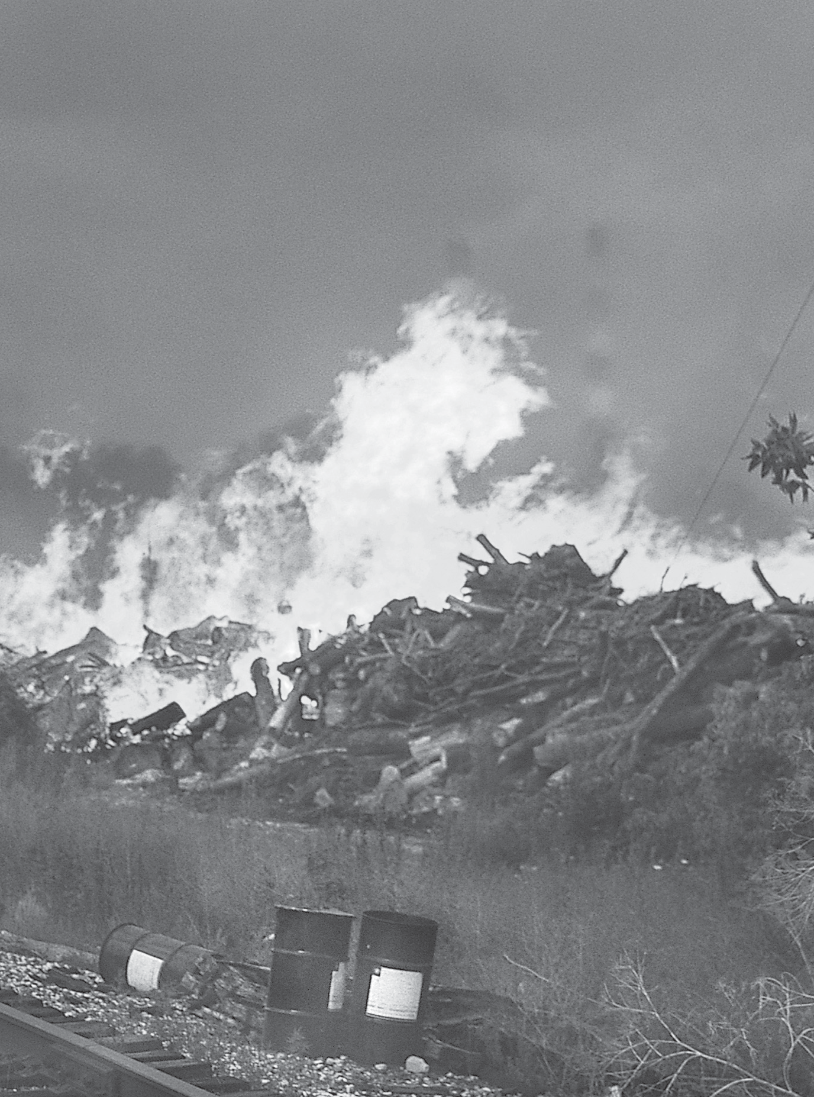When Should You Notify the TCEQ? 11

Appendix B:
TCEQ Areas and Regional Offices 12
Area and Regional Office Contacts 12 TCEQ Areas and Regions (map) 13

Appendix C:
Outdoor Burning Rule 14

Appendix D: Background 18

printed on recycled paper

2 TEXAS COMMISSION ON ENVIRONMENTAL QUALITY

Introduction
his guide helps interpret the revised Outdoor Burn­
ing Rule, Title 30, Texas Administrative Code,
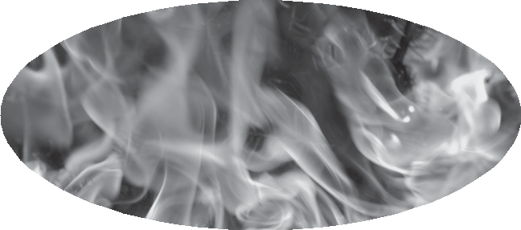1
T
How do I obtain a burning permit from the TCEQ?

You don’t. The TCEQ does not issue burning permits.

Sections 111.201–221,
for the general public, the
Outdoor burning in general is prohibited in Texas, although

regulated community, and responsible state and local officials.
This document covers all aspects of the outdoor burning rule, including:
• exceptions for allowable outdoor burning,
• general requirements for allowing outdoor burning, and
• notification requirements for allowable outdoor burning. At the end of various sections, common questions relat­
ing to the material in the section are answered.
State and local officials may find Appendixes C and D—a copy of the rule itself and background information for each section of the rule—to be particularly useful.
This guide is not a substitute for the actual rule. A current copy of the rule can be obtained from the TCEQ by calling 512-239-0028, or online at <www.tceq.state.tx.us/rules/>.

The Outdoor Burning
Rule Explained
The current version of the Outdoor Burning Rule is the result of a concerted effort to produce a streamlined, unambiguous rule that can be applied consistently and fairly throughout Texas. Its purpose is to protect the environment, promote public health and safety, and avoid nuisance condi­ tions through the sensible regulation of outdoor burning.

Summary of the Rule
The Outdoor Burning Rule first prohibits outdoor burn­ ing anywhere in Texas, and then allows exceptions for specific situations in which burning is necessary or does not pose a threat to the environment. The rule also prescribes condi­ tions that must be met to protect the environment and avoid other adverse impacts when burning is allowed. If burning seems necessary, but the situation does not fit an exception stated in the rule, then it is possible to request from the TCEQ a special authorization to conduct burning.

1 In this document, “30 TAC 111” is short for “Title 30, Texas Administrative Code, Section 111.”
the Outdoor Burning Rule (Appendix C) does allow certain exceptions. If your situation fits all requirements for one
of the exceptions described in the rule, you may conduct out­ door burning, as long as you comply with all the conditions. Depending on the circumstances, you may also need ap­ proval from the appropriate regional office before you burn. Remember also to check local ordinances or other regulations about burning.

It looks like I can get the TCEQ’s approval to burn, but my neighbors may complain. Do I have to worry about what they think?

Yes. In addition to common courtesy, the Outdoor Burn­ ing Rule requires that certain kinds of burning be conducted downwind of, or at least 300 feet from, any structure con­ taining sensitive receptors (for example, a residence, business, barn, or greenhouse; see box, page 6) located on adjacent properties unless written approval is obtained beforehand from the owner or occupant—the one who will suffer ad­ verse effects—of the adjacent or downwind property. Also, the burning must not cause a nuisance or traffic hazard.

The rule authorizes (or the TCEQ has authorized) my outdoor burning. Before I actually set the fire, do I have to notify the TCEQ?

It depends. For certain types of burning, the rule re­ quires you to notify the appropriate TCEQ regional office. For others, you are not required to notify the TCEQ. But, before you strike that match, remember that you may also have to contact other agencies—or even your neighbors—as well as the TCEQ. See Appendix A for the notification requirements for the various kinds of burning covered
under the rule. Even if the rule doesn’t require you to notify the TCEQ, you will find that the local regional office has
up-to-date information about weather conditions and other factors you should consider before conducting any outdoor

burning—for example, which way (and how fast) the wind is blowing, whether winds are expected to shift, whether your area is under a temperature inversion, and whether high ozone levels are forecast.

How do I report somebody who is conducting illegal outdoor burning?

Report the burning to the local air pollution control of­ fice, or the nearest TCEQ regional office. The TCEQ’s Envi­ ronmental Complaint Hotline is 888-777-3186. Complaints can also be submitted by e-mail at <cmplaint@tceq.state.tx.us> or on the agency web site using the online form.

Exceptions to the Prohibition
The standard exceptions, explained below, cover the most common situations in which burning is an accept­ able practice. In most of these instances, the burning
must follow the general requirements outlined later in this document. It may be necessary to notify the TCEQ, local governmental agencies, and neighbors before conducting burning under one of these exceptions. See Appendix A for details on notification requirements in specific situations. There may be local ordinances or county burn bans that regulate burning; if so, the requirements and restrictions of those ordinances must also be met.

Firefighter Training
Organizations that train firefighters may obtain au­ thorization to conduct outdoor burning for such training, including training in the operation of fire extinguishers. To obtain an authorization, the organization responsible for the training must send a written request to the local air pollution control agency under contract with the TCEQ or, if there is no such agency, the appropriate TCEQ regional office. For a list of regional offices, see Appendix B.
If training occurs regularly at a dedicated facility, it may be possible to inform the regional office of all such training events with one annual written notification. If a dedicated training facility conducts training regularly but less often than once a week, a telephone or fax notification will be necessary 24 hours in advance of each event.
Burning conducted to train firefighters does not have to conform to the general requirements for other forms of al­ lowable outdoor burning, but it must not cause a nuisance or traffic hazard. The TCEQ may revoke its authorization if it
is used in an attempt to avoid complying with other portions of the Outdoor Burning Rule.
We want to conduct fire training for our volunteer fire department.
Can we burn this abandoned house?

The training of firefighters may be authorized as an exception to the prohibition on outdoor burning. Submit a written request on behalf of the VFD to the local air pol­ lution control agency, or, if there is no local agency, the TCEQ office for your region. The TCEQ may authorize such training orally or in writing; if it denies the request, your
VFD will receive a notice of denial within 10 working days after the postmark date or the date of personal delivery of the request to the regional office. To ensure that the fire will not form or disperse toxic substances, the local air pollution control agency or the reviewing TCEQ regional office may require that the building be stripped of many common con­
struction materials—including electrical wiring, lead flashing, carpet, asbestos, and many others—before the fire is ignited. Note that the burning of abandoned buildings by a fire
department is not automatically considered fire training. There must be a specific benefit to the fire department. Sim­ ply preventing the spread of fire from an abandoned building to neighboring property is not considered training. Such burns constitute an attempt to circumvent the prohibitions
in the Outdoor Burning Rule and are prohibited.

Fires for Recreation, Ceremonies, Cooking, or Warmth
Outdoor burning is allowed when used solely for recreational or ceremonial purposes, in the noncommercial preparation of food, or exclusively as a means of generating warmth in cold weather. In other words, campfires, bonfires, and cooking fires are allowed. Fires built under this exception may not contain electrical insulation, treated lumber, plastics, construction or demolition materials not made of wood, heavy oils, asphaltic materials, potentially explosive materi­ als, chemical wastes, or items containing natural or synthetic rubber. The other general requirements on allowable outdoor burning do not apply to fires covered by this exception, but the burning must not cause a nuisance or traffic hazard.

May I cook food on my charcoal grill in my backyard?

Yes. Fires used in the noncommercial preparation of food are allowed.

May I build a fire in my fireplace?

Yes. Indoor fires are not regulated by the Outdoor Burn­ ing Rule. Domestic-use fireplaces are authorized under the TCEQ’s de minimis rules in 30 TAC 116.119.

Are campfires allowed inside the city limits?

Sometimes. Fires used solely for recreation or ceremony are allowed by state law; however, local ordinance may prohibit this kind of burning. Make sure no oils, asphalt, synthetic rubber, or other materials that produce heavy smoke are in the fire: they could release toxic gases or cause a nuisance or traffic hazard.

Fires for Disposal or Land Clearing
A broad exception for fires to dispose of waste or clear land covers seven more specific categories, described below. Residents of Montgomery County are subject to special re­ strictions (see below); these restrictions could be extended to other areas of the state should growth in neighboring coun­ ties render them subject to the provisions of Local Govern­ ment Code 352.082.
1. Domestic waste. Domestic waste—in other words,
household trash or rubbish—may be burned when the local governmental organization with jurisdiction over such mat­ ters does not collect trash and does not authorize a business or other service to do so. To qualify for this exception, the waste must come from a property that is (1) designed to
be a private residence and (2) used exclusively as a private residence for no more than three families. The waste must also be burned on the property where it was produced. Ac­ cording to TCEQ rules [30 TAC 101.1(26)], domestic wastes include wastes that normally result from the function of life within a residence—for example, kitchen garbage, untreated lumber, cardboard boxes, packaging, clothing, grass, leaves, and branch trimmings. Such things as tires, construction debris, furniture, carpet, electrical wire, and appliances are not considered to be domestic waste and cannot be burned. Other conditions of the general requirements for outdoor burning do not apply to the burning of domestic waste, but
the outdoor burn must not cause a nuisance or traffic hazard.
2. Diseased animal carcasses. These may be burned when burning is the most effective means of controlling
the spread of disease. The general requirements for outdoor burning do not apply to this exception, but burning under this exception must not cause a nuisance or traffic hazard.
3. Burning of animal remains by a veterinarian. A vet­ erinarian may burn animal remains and medical waste—not including sharps (e.g., needles)—associated with animals in his or her care on his or her property if the property is lo­ cated outside the corporate boundaries of a municipality (or within the corporate boundaries of a municipality if annexed on or after September 1, 2003). This section prevails over
any other law that authorizes a governmental entity to abate a public nuisance. (Occupations Code 801.361.)
4. On-site burning of waste plant growth. Trees, brush, grass, leaves, branch trimmings, or other plant growth may be burned on the property on which the material grew. The plant growth must be burned by the property owner or any other person authorized by the owner. Additional require­ ments and restrictions apply depending on the attainment status of the county where the burning takes place.
All designated nonattainment counties and some attainment counties. Burning of waste plant growth is allowed only if the material was generated as a result of right-of-way maintenance, land clearing, or maintenance along water canals. Burning in these areas is allowed
only when no practical alternative exists. Burning carried out under this exception must conform to all the general requirements for outdoor burning.
Most attainment counties. Burning of waste plant growth is allowed regardless of the activity that gener­ ated the material. Practical alternatives need not be considered. Burning carried out under this exception must conform to some of the general requirements for outdoor burning, specifically the burning must conform to the requirements in 30 TAC 111.219(3, 4, 6, 7)
(see Appendix C). Such burning is also subject to local ordinances which prohibit burning in the corporate limits of a city or town. Some attainment counties are
treated as nonattainment counties for the purposes of this exception. Specifically, any attainment county that contains any part of a municipality that extends into a bordering nonattainment county is treated as a nonat­ tainment county for the purposes of this exception.
To determine if your county is an attainment or a nonat­ tainment county for the purposes of this exception, call your regional TCEQ office. TCEQ regional office phone numbers appear in Appendix B.
5. Designated burn sites. This exception allows rural homeowners to transport their yard waste to a designated site for consolidated burning, rather than having numerous
smaller fires in the yards of rural neighborhoods. All burning at a designated site must be directly supervised by a fire- department employee. Designated burn sites must be located outside the corporate limits of a municipality and within
a county that has a population of less than 50,000. The site must be designated by its owner; designation does not require registration with the agency. A site is designated by:
• posting all entrances to the site with a placard measur­ ing at least 2 feet wide by 4 feet high bearing specific information as provided in 30 TAC 111.209(5)(A) (see Appendix C)—each placard must be clearly visible and legible at all times; and

• specifying residential properties for which the site has been designated, and maintaining a record of those specific residential properties. The record must contain
a description of a platted subdivision, a list of all specific residential addresses, or both. This record must be made available within 48 hours of any request by any author­ ity having jurisdiction.
Furthermore, the owner of the site is required to ensure that all activities at the site comply with this exception. The owner must:
• ensure that all waste burned at the site consists of trees, brush, grass, leaves, branch trimmings, or other plant growth, and was generated at one of the specific residen­ tial properties for which the site is designated; and
• ensure that all burning at the site is directly supervised by a paid, on-duty fire department employee who is
part of the fire protection personnel and is acting in the scope of his or her employment. The fire-department employee must notify the appropriate TCEQ regional office by phone or fax 24 hours in advance of each burn. The TCEQ will supply the employee with information on practical alternatives to burning.
6. Crop residues. When there is no practical alterna­ tive, crop residues may be burned as part of agricultural management. Burning carried out under this exception must conform to the general requirements for outdoor burning, and structures containing “sensitive receptors” (see box) must not be negatively affected by the burn. This exception does not apply to crop-residue burning covered by an administra­ tive order.

“Sensitive receptors” include humans and live­ stock, as well as “sensitive live vegetation” such as nursery plants, mushrooms under cultivation, and plants raised for pharmaceutical production or used in lab experiments. For a complete definition, see 30 TAC 111.203(7).

7. Brush, trees, etc., off-site. A county or municipal government may request site and burn approval from the appropriate TCEQ regional office to burn accumulations of brush, trees, and other plant growth that cause a condi­
tion detrimental to public health and safety. The burn must occur at a site owned by the local government and will be authorized only if the TCEQ determines that there is no practical alternative. The frequency of such burns may not exceed once every two months, and they cannot be used in place of other sound brush-management practices. Burning conducted under this exception must conform to the general
requirements for allowable outdoor burning. The burning may not occur at a municipal landfill without advance per­ mission from the TCEQ.
Special restrictions in Montgomery County. Regardless of the seven exceptions given above, in unincorporated areas of Montgomery County it is a criminal offense, as well as a violation of agency rules, to burn household refuse on a lot smaller than five acres or located in a “neighborhood.” The terms “neighborhood” and “refuse” are defined in 30 TAC
111.203 (see Appendix C). Under Local Government Code
352.082, this restriction could in the future also apply to certain planned communities if a county adjacent to the one where such a community is located grows to 3.3 million or more in population.

I live in a small rural town where most people have their trash picked up by a commercial trash collection service. I can’t afford to pay that money each month. May I burn my trash in a 55-gallon drum in my backyard?

If the local city ordinance does not make it mandatory that trash be picked up, and there is no governmentally authorized trash-collection service available to you, you may burn domestic waste on the property where it is produced,
as long as outdoor burning is not prohibited by local rule or ordinance and does not create a nuisance or a traffic hazard.

May I burn my old oil filters in a metal barrel on my property?

No. Take oil filters to an authorized recycling site, along with your used oil. You may call 800-CLEAN-UP for more information on recycling.

I want to burn boxes from my business. The TCEQ rules say that I may burn waste from my residence, but what about waste from my business?

According to the Outdoor Burning Rule, you can’t burn business waste. The exception that allows the burn­ ing of domestic waste applies only if the property is used
exclusively as a private residence and the local governmental authority does not provide or authorize the collection of waste at the premises where the waste is generated. There is no such exception for businesses. You should look into the possibility of recycling your boxes or find ways that you or others could reuse them.

We have a hard time disposing of scrap tires.
Will the TCEQ let us burn them?

No, for at least two good reasons. First, the rule specifi­ cally prohibits the outdoor burning of tires—and any other items that contain natural or synthetic rubber—because of the air pollution that would result. Second, Texas is at least as innovative as anywhere else in the world in finding good uses for waste tires. The TCEQ’s Scrap Tire Program (Field Operations, 512-239-0400, <www.tceq.state.tx.us/goto/ scrap_tires>) can give you more earth-friendly methods for disposing of those old tires.

What may be burned at municipal landfills?

Routine burning is not allowed at municipal landfills, unless otherwise authorized by the TCEQ in writing.

I am a licensed veterinarian. Do I need authorization to burn animals that died while in my care?

Not if you are located outside the corporate boundaries of a municipality (or within the corporate boundaries of a municipality if annexed on or after September 1, 2003) and you burn the animal remains on property owned by you. You can also burn medical waste associated with the animal, with the exception of sharps (e.g., needles). For details, see section
801.361 of the Texas Occupations Code.

May I burn trees that I have cut down in my backyard?

That depends on several factors.
First, grass, leaves, and hedge and branch trimmings from residences are all considered “domestic waste.” If your local government does not collect domestic waste and does not au­ thorize a private collector to do so, this type of material may be burned. If such waste collection is available, then it cannot be burned under the domestic-waste exception.
Second, if you are in an attainment county which does not contain any part of a city that extends into a nonattain­ ment county, plant waste (not all domestic waste) may be burned on the property on which it was generated.
Finally, if your residential property has been identified and listed at a designated burn site, plant waste generated on your property may be transported to the designated burn site for consolidated burning.
However, under all of these exceptions, the burning must not create a nuisance or traffic hazard, and you must comply with all applicable local rules or ordinances.
I have some uncleared property inside the city limits that I would like to develop. Hauling the trees and brush off would not be practical because it is too expensive. May I dispose of the trees and brush by burning?

It depends on the attainment status of the county in which you wish to burn. In designated nonattainment coun­ ties, and attainment counties that border nonattainment counties and contain any part of a city that extends into the nonattainment county, this type of burning does not meet the exception unless the municipal government has enacted ordinances that permit burning consistent with state law.
You must consider alternatives such as chipping or trench burning. If there is no practical alternative, and the city has not enacted ordinances that permit burning, you may request written permission from the TCEQ for authorization to
burn, and you cannot commence with the burning until you receive such authorization. Such requests are evaluated on a case-by-case basis. Contact the appropriate TCEQ regional office for guidance.
In all other counties this burning meets the agency excep­ tion unless the municipal government has enacted ordinances that prohibit burning.
Contact the appropriate TCEQ regional office for infor­
mation on the attainment status of the applicable county.

I am in the business of trimming people’s trees and shrubs in town. I realize that the tree limbs and trimmings can’t be burned in town, but I own some land outside of town. May I take it out there and burn it?

No. The Outdoor Burning Rule allows the burning of land clearing materials only at the site where the land clearing is done. In order to burn under state law, that site must be out­ side of municipal corporate limits, unless the city or town has an ordinance, consistent with state law, that permits burning.

Why are sugar growers allowed to burn their cane fields?

There are no technically or economically feasible alter­ natives. Years ago, the Rio Grande Valley Sugar Growers, Inc., requested the authorization to burn the cane fields in association with each harvest. The TCEQ, after extended air monitoring studies, concluded that no practical alternative existed for this industry. The agency then adopted an agreed order that outlines conditions under which the sugarcane industry can conduct burning.

The burning of corn stubble produces a great amount of smoke. Is this type of burning authorized?

Burning for crop management is allowed if there is no practical alternative, if it is conducted under appropriate weather conditions and at appropriate times, and if it does not cause a nuisance or traffic hazard.

There are tree limbs in an area of our community that pose a public-safety risk.
What are our options for solving this problem?

Brush, trees, and other forms of plant growth that present a detriment to public health and safety may be burned by
a county or municipal government at a site it owns upon receiving site and burn approval from the TCEQ. Such burning can only be authorized when there is no practical alternative, and it may be done no more than once every two months. The local government has the burden of proving
that there is no practical alternative and that the growth poses a detriment to public health or safety. Burning to augment normal brush disposal cannot be a continual or a standard operating procedure and cannot be conducted at municipal landfills unless authorized in writing by the TCEQ.

Is hay that has been used as bedding material for animals considered crop residue?

No. Hay used for this purpose will need to be properly disposed of by a method other than burning. Check with your local county officials or agricultural organizations. They may need this material for erosion control or other purposes.

Prescribed Burns
This exception covers the use of fire to manage forests, rangeland, wildland and wildlife, and, in 14 counties, coastal salt marsh. All of these forms of burning are subject to the general requirements for allowable outdoor burn­ ing. Coastal salt-marsh burning also entails more specific notification requirements, which are stated in 30 TAC
111.211(2)(A) and (B).

Who can I contact for technical information relating to prescribed burning?

A good source is the Prescribed Burning Board of the Texas Department of Agriculture, which sets standards for prescribed burning; develops a comprehensive training cur­
riculum for prescribed-burn managers and sets standards for their certification, recertification and training; establishes minimum education and professional requirements for instructors for the approved curriculum; and sets minimum insurance requirements for prescribed-burn managers.
For safety reasons, a prescribed-burn plan may call for burning at night. Such a plan requires special authorization and must consider the effects of a temperature inversion on smoke dispersal in order to protect public health.

Pipeline Breaks and Oil Spills
An oil (or other hydrocarbon) spill or pipeline break may trigger a requirement to notify the appropriate TCEQ regional office. Once notified of the spill, the regional office staff will decide whether burning is neces­ sary to protect the public welfare. If the TCEQ gives the company or person responsible for the spill permission to
burn, the TCEQ may also require that company or person to take samples and monitor the site to determine and evaluate environmental impacts.

Other Situations
If a situation seems to require outdoor burning, but it is not covered by the previously described exceptions, you may request permission to burn from the TCEQ regional office. Its staff, acting on behalf of the executive director,
will consider whether there is a practical alternative, whether the burning will cause or contribute to a nuisance or traffic hazard, and whether the practice will violate any federal or state primary or secondary standard for ambient air qual­
ity. Such an authorization may require you to follow certain procedures to control or abate emissions. The authorization may be revoked at any time if the TCEQ determines that the outdoor burning is creating a nuisance, violating any provision of an applicable permit, causing a violation of any air quality standard, or not conforming to the conditions specified in the authorization.

A bad storm knocked a lot of trees down
in our community. May we burn the debris? May we haul it to the landfill and burn it?

Regardless of whether the brush is to be burned on-site or at the landfill, this type of burning is not specifically authorized in the exceptions to the prohibition on outdoor burning. However, the TCEQ may authorize the disposal of storm debris if there are no practical alternatives. Such requests are evaluated on a case-by-case basis. Contact the appropriate TCEQ regional office for guidance.

Why are housing subdivisions allowed to dig pits and burn their land-clearing materials within city limits?

They are using a process called air-curtain incinera­ tion (trench burning), which is authorized under a permit by rule or standard permit. Companies that specialize in that business must obtain prior TCEQ approval, obtain
a federal operating permit, and follow specific written operating procedures.

General Requirements for Burning
The Outdoor Burning Rule sets the following general requirements for allowable outdoor burning. These require­ ments apply to the specific situations for which they are mentioned above. They are designed to reduce the likelihood that burning will create a nuisance, cause a hazard, or harm the environment. The party responsible for the burn remains liable for damages, injuries, or other consequences that may result from burning, even when it is carried out in compli­ ance with these regulations.
Notify the Texas Forest Service before carrying out any prescribed or controlled burns that are intended for forest management.
Burn only outside the corporate limits of a city or town, unless the incorporated city or town has an ordinance, consistent with the Texas Clean Air Act, Subchapter E, that permits burning.
Commence or continue burning only when the wind
direction and other weather conditions are such that the smoke and other pollutants will not present a hazard to any public road, landing strip, or navigable water (e.g., lake,
river, stream, or bay) or have an adverse effect on any off-site structure containing “sensitive receptors” (e.g., a residence, business, farm building, or greenhouse; see box, page 6).
Post someone to flag traffic if at any time the burning causes or may tend to cause smoke to blow onto or across a road or highway.
Keep fires downwind of, or at least 300 feet away from, any neighboring structure that contains sensitive receptors. This requirement may be waived only with the prior written approval of whoever owns or rents the adjacent property and either resides or conducts business there.
Begin burning no earlier than one hour after sunrise, end it the same day and no later than one hour before sunset, and make sure that a responsible party is present while the burn is active and the fire is progressing. At the end of the burn, extin­ guish isolated residual fires or smoldering objects if the smoke they produce can be a nuisance or a traffic hazard. Don’t start
burning unless weather conditions are such that the smoke will dissipate (winds of at least 6 miles per hour; no temperature inversions) while still allowing the fire to be contained and controlled (winds no faster than 23 miles per hour).
Don’t burn any electrical insulation, treated lumber, plastics, non-wooden construction or demolition materi­ als, heavy oils, asphaltic materials, potentially explosive materials, chemical wastes, or items that contain natural or synthetic rubber.

My situation doesn’t fit any of the exceptions given in the rule, but I still think that burning is the only practical alternative. What can I do?

Submit a written request to the TCEQ regional office that serves the county where you wish to conduct outdoor burning. Acting on behalf of the executive director, the regional staff will review your request and determine whether no practical alternative is available. If they agree that none
can be found, they will issue you a written authorization to burn that outlines specific conditions you must follow to control the emissions.

We are burning in compliance with TCEQ regulations, but the local fire marshal objects. Is our compliance with state rules not enough?

Your compliance with TCEQ regulations does not mean that other, stricter laws, regulations, or ordinances cannot be enforced by cities, counties, or other jurisdictions. You must comply with all such regulations (e.g., county burn bans) as well as the TCEQ rules.

Practical Alternatives to Burning
The Outdoor Burning Rule defines a practical alternative as “an economically, technologically, ecologically, and logisti­ cally viable option.” The following methods can sometimes serve as practical alternatives to burning as a means to
dispose of waste. With creative thinking and the help of the local TCEQ regional office, you may be able to develop ways to dispose of your waste other than burning it.
Recycling. Manually or mechanically separate salvageable metals from other material, and sell them at a salvage yard.
Composting. Wastes from landscape maintenance can of­ ten be composted on-site easily and cleanly. Similar wastes— even paper, in some instances—can be composted under the right conditions.
Mechanical chipping or mulching. The mulch that is pro­ duced could be put to use for soil enrichment and moisture retention, or used to create compost. In some cases, the

mulch could become a marketable product, be put to use where it is produced, or be given to individuals or nurseries. If the material cannot be used as a landscape mulch, chip­ ping can still be useful to reduce the volume of waste that must be disposed of by some other means.
Logging. Timber sometimes can be converted to a mar­ ketable product—lumber, pulp, or firewood—as one way to reduce the costs of disposal. The remaining small limbs and brush are then much easier to dispose of through one of the other alternatives.
Landfills. Some landfills have recycling centers, with chip­
pers for wood waste and collection bins for paper, plastic, and glass. Type IV landfills accept brush. Contact your local landfills for details.
Air-curtain incineration (trench burning). Many land clearing contractors have portable devices, known as trench burners or air-curtain incinerators, that can be used to dispose of brush or untreated lumber with minimal emissions. These facilities must be authorized by the TCEQ prior to their
construction at a burn site and must have obtained a federal operating permit. Many contractors and distributors lease out these devices.

Related TCEQ Publications
The TCEQ has a variety of publications available on issues related to outdoor burning. Several of them provide detailed explanations of specific alternatives to outdoor burn­ ing, for example:
RG-325: Used Oil Recycling Handbook: Guidance for
Used Oil Handlers
GI-036: Composting and Mulching
RG-419: Disposal of Domestic or Exotic Livestock Carcasses

To order single copies of these or other TCEQ publica­ tions, call TCEQ Publications Distribution at 512-239-0028 or write:
TCEQ Publications, MC-195
P.O. Box 13087
Austin, TX 78711-3087

Appendix A
Outdoor Burning—When Should You Notify the TCEQ?

Purpose of Burning | Notify the TCEQ | Who Else to Notify | Rule Section
Fire Training
Statewide | In writing, 10 working days prior | 1 | 111.205(a)
Dedicated facility, used at least once per week | Every year | 1 | 111.205(b)
Dedicated facility, used less frequently | Every year | 1 | 111.205(c)
Disposal
Domestic waste | Not required | 2 | 111.209(1)
Diseased animal carcasses | Not required | 2 | 111.209(2)
Animal remains and associated medical waste | Not required | 2 | 111.209(3)
Plant growth on-site | Not required | 2, 4 | 111.209(4)
Plant growth at designated burn site | Orally or in writing, by fire department employee; must be 24 hours before event | 2, 4 | 111.209(5)
Crop residue | Orally or in writing, when possible | 2, 4 | 111.209(6)
Brush, off-site, by county or city | In writing; also notify orally when possible | 2, 4 | 111.209(7)
Prescribed burns
Other than coastal salt marsh | Orally or in writing, when possible | 2, 3, 4 | 111.211(1)
Coastal salt marsh | 15 working days prior,  in writing; oral notification also required | 4 | 111.211(2)(A)
Other
Oil spills | Spill notification and prior approval, in writing; oral notification also required | 2 | 111.213
Ceremonial fires | Not required | 2 | 111.207
Note: This table shows notification requirements only. See also the general requirements for allowable burning given later in this document.
1. If there is a local air pollution control agency, notify that agency.
2. Check local ordinances, and notify any other government having jurisdiction over the area—for example, the county fire marshal, local fire department, or local law enforcement officials.
3. Notify the Texas Forest Service before conducting prescribed burns for forest management.
4. Before conducting the burn, determine whether any “structures containing sensitive receptors” (for example, residences, greenhouses, stables, etc.) are within 300 feet of and in the general direction downwind from the site of the burn. If so, obtain written permission from the occupants or operators of those structures before you begin the burn.

Appendix B
TCEQ Areas and Regional Offices

Area and Regional Office Contacts

TCEQ AREA OFFICES

BORDER AND SOUTH CENTRAL TEXAS
Region 6, El Paso Region 11, Austin Region 13, San Antonio Region 15, Harlingen Region 16, Laredo
Area Director: Ramiro Garcia, MC 174
P.O. Box 13087
Austin, TX 78711-3087
512-239-2953 • FAX: 512-239-0404

1 – AMARILLO
Regional Director: Brad Jones
3918 Canyon Dr.
Amarillo, TX 79109-4933
806-353-9251 • FAX: 806-358-9545

Perryton Office
511 South Main
Perryton, TX 79070
806-435-8059 • FAX: 806-434-8443

2 – LUBBOCK
Regional Director: Randy Ammons
5012 50th St., Ste. 100

COASTAL AND EAST TEXAS

Region 5, Tyler
Region 10, Beaumont Region 12, Houston Region 14, Corpus Christi
Area Director: David Bower, MC 174
P.O. Box 13087
Austin, TX 78711-3087
512-239-2953 • FAX: 512-239-0404

TCEQ REGIONAL OFFICES
6 – EL PASO
Regional Director: Lorinda Gardner
401 E. Franklin Ave., Ste. 560
El Paso, TX 79901-1212
915-834-4949 • FAX: 915-834-4940

7 – MIDLAND
Regional Director: Jed Barker
3300 N. A St., Bldg. 4-107
Midland, TX 79705-5406
432-570-1359 • FAX: 432-570-4795

8 – SAN ANGELO

NORTH CENTRAL AND WEST TEXAS

Region 1, Amarillo Region 2, Lubbock Region 3, Abilene
Region 4, Dallas/Fort Worth
Region 7, Midland Region 8, San Angelo Region 9, Waco
Area Director: Brent Wade, MC 174
P.O. Box 13087
Austin, TX 78711-3087
512-239-6566 • FAX: 512-239-0404

12 – HOUSTON
Regional Director: Donna Phillips
5425 Polk St., Ste. H Houston, TX 77023-1452
713-767-3500 • FAX: 713-767-3520

13 – SAN ANTONIO
Regional Director: Richard Garcia
14250 Judson Rd.
San Antonio, TX 78233-4480
210-490-3096 • FAX: 210-545-4329

South Texas Watermaster Office
210-490-3096 • FAX: 210-545-4329
1-800-733-2733

Lubbock, TX 79414-3426
806-796-7092 • FAX: 806-796-7107
Regional Director: Ricky Anderson
622 S. Oakes, Ste. K

3 – ABILENE
Regional Director: Winona Henry
1977 Industrial Blvd. Abilene, TX 79602-7833
325-698-9674 • FAX: 325-692-5869

4 – DALLAS/FORT WORTH
Regional Director: Tony Walker
2309 Gravel Dr.
Fort Worth, TX 76118-6951
817-588-5800 • FAX: 817-588-5700

Stephenville Office
(Confined Animal Feeding Operations)
580-D W. Lingleville Rd.
Stephenville, TX 76401
254-965-9200 or 1-800-687-7078

5 – TYLER
Regional Director: Leroy Biggers
2916 Teague Dr.
Tyler, TX 75701-3734
903-535-5100 • FAX: 903-595-1562
San Angelo, TX 76903-7035
325-655-9479 • FAX: 325-658-5431

Concho Watermaster Office
325-481-8069 or 1-866-314-4894
FAX: 325-658-5431

9 – WACO
Regional Director: Anna Dunbar
6801 Sanger Ave., Ste. 2500
Waco, TX 76710-7826
254-751-0335 • FAX: 254-772-9241

10 – BEAUMONT
Regional Director: Georgie Volz
3870 Eastex Fwy.
Beaumont, TX 77703-1830
409-898-3838 • FAX: 409-892-2119

11 – AUSTIN
Regional Director: Patty Reeh
2800 S. IH 35, Ste. 100
Austin, TX 78704-5700
512-339-2929 • FAX: 512-339-3795
14 – CORPUS CHRISTI
Regional Director: Susan Clewis
NRC Bldg., Ste. 1200
6300 Ocean Dr., Unit 5839
Corpus Christi, TX 78412-5839
361-825-3100 • FAX: 361-825-3101

15 – HARLINGEN
Regional Director: David A. Ramirez
1804 W. Jefferson Ave. Harlingen, TX 78550-5247
956-425-6010 • FAX: 956-412-5059

Rio Grande Watermaster Office
956-430-6056 or 1-800-609-1219
FAX: 956-430-6052

Eagle Pass Office
1152 Ferry St., Ste. H
Eagle Pass, TX 78852-4367
830-773-5059 • FAX: 830-773-4103

16 – LAREDO
Regional Director: David A. Ramirez
707 E. Calton Rd., Ste. 304
Laredo, TX 78041-3887
956-791-6611 • FAX: 956-791-6716

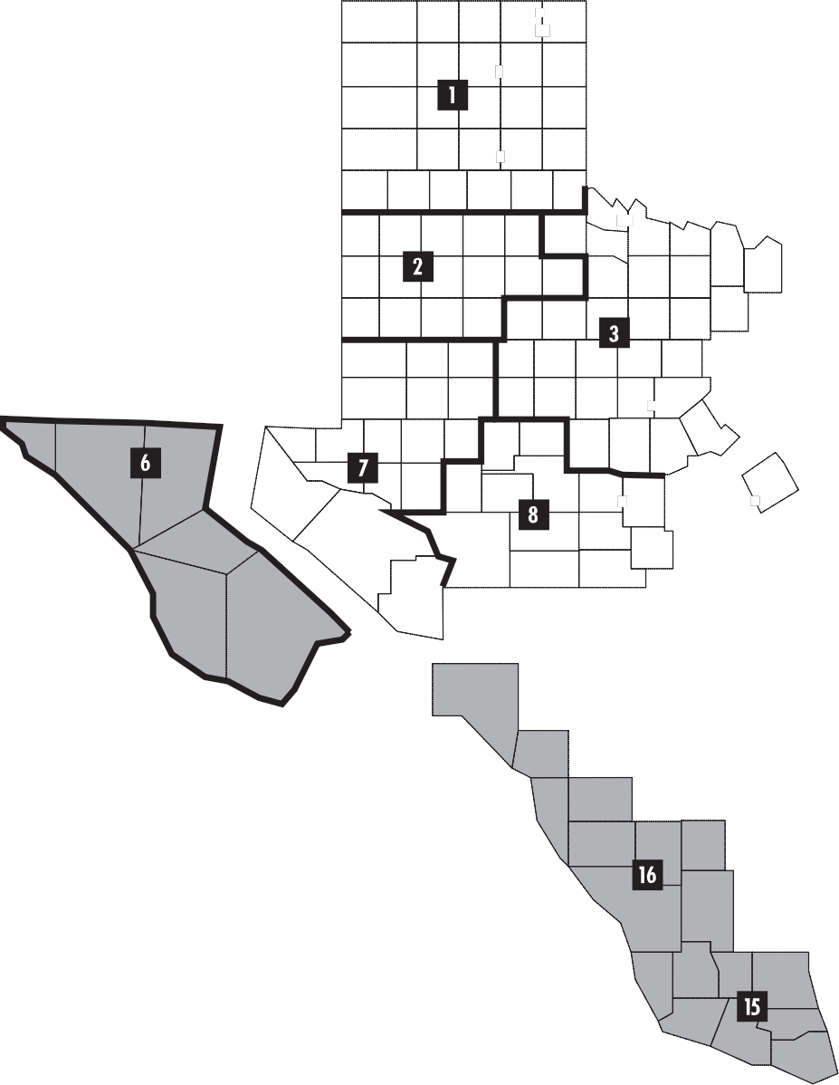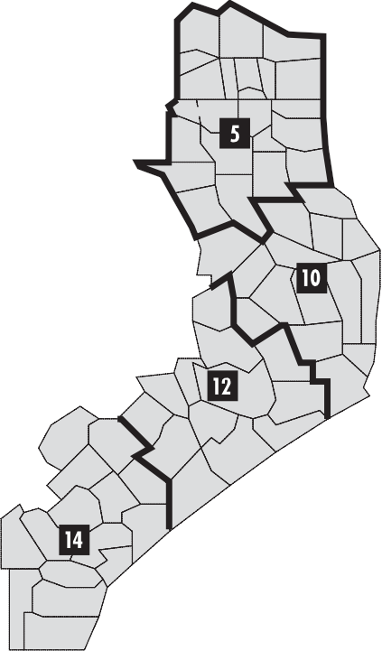TCEQ Areas and Regional Offices (continued)

Dallam
Sherman
Hansford
Ochiltree
Lipscomb

Moore Roberts

Hartley

Oldham

Potter
Hutchinson

Gray
Carson
Hemphill

Wheeler

NORTH CENTRAL AND WEST TEXAS AREA

Deaf Smith
Randall Donley
Armstrong

Collings­
worth

Parmer

Castro Briscoe
Swisher

Child- ress
Hall

Bailey

Cochran

Lamb

Hale

Floyd

Crosby

Motley

Dickens

Cottle

King
Hardeman
Wichita
Foard
Wilbarger
Archer
Knox Baylor

Clay
Montague

Cooke

Grayson

Fannin

Hockley Lubbock
Lynn Garza

Kent Haskell Throck­

Jack

Denton
Collin Hunt

Terry
Yoakum
Dawson

Scurry
Stonewall
morton Young

Shackel­

Palo
Wise

Parker

Rockwall
Kauf­

Lamar

Red
River

Bowie

Gaines

Martin
Borden

Mitchell
Fisher Jones

Taylor
ford Stephens Pinto
Eastland
Tarrant Dallas man
Hood Johnson Ellis
vell
Delta
Hopkins

Titus

Cass

Andrews
Howard Nolan
Callahan
Erath Somer­

Hill

Navarro
Camp
Rains Wood Upshur Marion
Morris

El Ector Glass-
Coke
Coleman
Comanche
Bosque
Harrison

Paso Hudspeth
Loving Winkler
Midland cock
Sterling
Runnels Brown
Lime­ Free­
Van
Gregg

Culberson

Reeves

Ward

Crane Upton

Reagan

Irion

Tom
Green

Concho

Mills
Hamilton
Coryell
McLennan
Falls
stone
stone

Leon
Zandt
Henderson
Smith

Rusk

Panola

McCulloch
San
Lampasas
Shelby

Jeff
Davis

Presidio

Brewster

Pecos Crockett Schleicher
Sutton

Terrell

Menard

Kimble

Mason
Saba Bell

Burnet
Robertson
Milam
Brazos

Houston

Trinity

Walker San

Angelina

Polk
Tyler

Sabine

Jasper
Newton

Llano

Gillespie Blanco
Williamson
Travis Lee
Jacinto

Montgomery

Hardin

Orange

Val Verde
Edwards Kerr
Hays Bastrop
Liberty
Jefferson

Real
Kendall
Bandera Comal
Caldwell
Fayette
Austin
Harris
Chambers

Bexar
Guadalupe
Colorado
Ft.
Bend Galveston

Kinney
Maverick
Uvalde

Medina

Wilson
Lavaca
Wharton

Brazoria

BORDER AND SOUTH

Zavala

Frio

La

Atascosa Karnes

Mc-

Bee
DeWitt

Goliad
Jackson Matagorda
Victoria
Calhoun

CENTRAL TEXAS AREA
Dimmit
Salle

Webb
Mullen

Duval
Live
Oak
Jim Wells

San
Patricio
Nueces

Kleberg
Refugio

COASTAL AND

Jim
Hogg
Brooks

Kenedy
EAST TEXAS AREA

Starr

Hidalgo
Willacy

Cameron

TCEQ REGIONS

1 AMARILLO
2 LUBBOCK
3 ABILENE
4 DALLAS/FORT WORTH
5 TYLER
6 EL PASO
7 MIDLAND
8 SAN ANGELO
9 WACO
10 BEAUMONT
11 AUSTIN
12 HOUSTON
13 SAN ANTONIO
14 CORPUS CHRISTI
15 HARLINGEN
16 LAREDO

Appendix C
Outdoor Burning Rule

The Outdoor Burning Rule is reproduced below from
30 TAC 111.201–221. A current copy of the rule can be obtained from the TCEQ by calling 512-239-0028, or at
<www.tceq.state.tx.us/rules/>.

§111.201. General Prohibition.
No person may cause, suffer, allow, or permit any out­ door burning within the State of Texas, except as provided by this subchapter or by orders or permits of the commission. Outdoor disposal or deposition of any material capable of igniting spontaneously, with the exception of the storage of solid fossil fuels, shall not be allowed without written permis­ sion of the executive director. The term “executive director,” as defined in Chapter 3 of this title (relating to Definitions), includes authorized staff representatives.

§111.203. Definitions.
Unless specifically defined in the Texas Clean Air Act (TCAA) or in the rules of the Texas Commission on En­ vironmental Quality (commission), the terms used by the commission have the meanings commonly ascribed to them in the field of air pollution control. In addition to the terms that are defined by the TCAA, the following terms, when used in this chapter, have the following meanings, unless the context clearly indicates otherwise.
(1) Extinguished—The absence of any visible flames, glowing coals, or smoke.
(2) Landclearing operation—The uprooting, cutting, or clearing of vegetation in connection with conver­ sion for the construction of buildings, rights-of-way, residential, commercial, or industrial development, or the clearing of vegetation to enhance property value, access, or production. It does not include the mainte­ nance burning of on-site property wastes such as fallen limbs, branches, or leaves, or other wastes from routine
property clean-up activities, nor does it include burning following clearing for ecological restoration.
(3) Neighborhood—A platted subdivision or property contiguous to and within 300 feet of a platted subdivision.
(4) Practical alternative—An economically, technologi­
cally, ecologically, and logistically viable option.
(5) Prescribed burn—The controlled application of fire to naturally occurring vegetative fuels under specified environmental conditions and confined to a predeter­ mined area, following appropriate planning and precau­ tionary measures.
(6) Refuse—Garbage, rubbish, paper, and other decay- able and nondecayable waste, including vegetable matter and animal and fish carcasses.
(7) Structure containing sensitive receptor(s)—A man-made structure utilized for human residence or business, the containment of livestock, or the housing of sensitive live vegetation. The term “man-made structure” does not include such things as range fences, roads, bridges, hunting blinds, or facilities used solely for the storage of hay or other livestock feeds. The term “sensi­ tive live vegetation” is defined as vegetation that has potential to be damaged by smoke and heat, examples of which include, but are not limited to, nursery produc­ tion, mushroom cultivation, pharmaceutical plant production, or laboratory experiments involving plants.
(8) Sunrise/Sunset—Official sunrise/sunset as set forth in the United States Naval Observatory tables available from National Weather Service offices.
(9) Wildland—Uncultivated land other than fallow, land minimally influenced by human activity, and land maintained for biodiversity, wildlife forage production, protective plant cover, or wildlife habitat.

§111.205. Exception for Fire Training.
(a) Outdoor burning shall be authorized for train­ ing firefighting personnel when requested in writing and when authorized either verbally or in writing by the local air pollution control agency. In the absence of such local entities, the appropriate commission regional office shall be notified. The burning shall be authorized if notice of denial from the local air pollution control agency, or com­ mission regional office is not received within 10 working days after the date of postmark or the date of personal delivery of the request.
(b) Facilities dedicated solely for firefighting training, at which training routinely will be conducted on a frequency

of at least once per week, shall submit an annual written notification of intent to continue such training to the appro­ priate commission regional office and any local air pollution control agency.
(c) Facilities dedicated solely for firefighting training, at which training is conducted less than weekly, shall provide an annual written notification of intent, with a telephone
or electronic facsimile notice 24 hours in advance of any scheduled training session. No more than one such notifica­ tion is required for multiple training sessions scheduled within any one-week period, provided the initial tele­ phone/facsimile notice includes all such sessions. Both the written and telephone notifications shall be submitted to
the appropriate commission regional office and any local air pollution control agency.
(d) Authorization to conduct outdoor burning under this provision may be revoked by the executive director if the authorization is used to circumvent other prohibitions of this subchapter.

§111.207. Exception for Fires Used for
Recreation, Ceremony, Cooking, and Warmth.
Outdoor burning shall be authorized for fires used solely for recreational or ceremonial purposes, or in the noncom­ mercial preparation of food, or used exclusively for the purpose of supplying warmth during cold weather. Such burning shall be subject to the requirements of §111.219(7) of this title (relating to General Requirements for Allowable Outdoor Burning).

§111.209. Exception for Disposal Fires.
Except as provided in Local Government Code,
§352.082, outdoor burning is authorized for the following:

(1) domestic waste burning at a property designed for and used exclusively as a private residence, housing not more than three families, when collection of domestic waste is not provided or authorized by the local govern­ mental entity having jurisdiction, and when the waste
is generated only from that property. Provision of waste collection refers to collection at the premises where the waste is generated. The term “domestic waste” is defined in §101.1 of this title (relating to Definitions). Wastes normally resulting from the function of life within a res­ idence that can be burned include such things as kitchen garbage, untreated lumber, cardboard boxes, packaging (including plastics and rubber), clothing, grass, leaves, and branch trimmings. Examples of wastes not consid­ ered domestic waste that cannot be burned, include such
things as tires, non-wood construction debris, furniture, carpet, electrical wire, and appliances;

(2) diseased animal carcass burning when burning is the most effective means of controlling the spread of disease;

(3) veterinarians in accordance with Texas Occupations
Code, §801.361, Disposal of Animal Remains;

(4) on-site burning of trees, brush, grass, leaves, branch trimmings, or other plant growth, by the owner of the property or any other person authorized by the owner, and when the material is generated only from that property:
(A) in a county that is part of a designated nonat­ tainment area or that contains any part of a munici­ pality that extends into a designated nonattainment area; if the plant growth was generated as a result
of right-of-way maintenance, landclearing opera­ tions, and maintenance along water canals when no practical alternative to burning exists. Such burning is subject to the requirements of §111.219 of this title (relating to General Requirements for Allow­ able Outdoor Burning). Commission notification
or approval is not required; or

(B) in a county that is not part of a designated nonattainment area and that does not contain any part of a municipality that extends into a designated nonattainment area; this provision includes, but is not limited to, the burning of plant growth gener­ ated as a result of right-of-way maintenance, land- clearing operations, and maintenance along water canals. Such burning is subject to local ordinances that prohibit burning inside the corporate limits of
a city or town and that are consistent with the Texas Clean Air Act, Chapter 382, Subchapter E, Author­ ity of Local Governments, and the requirements of
§111.219(3), (4), (6), and (7) of this title. Commis­
sion notification or approval is not required.

(5) at a site designated for consolidated burning of waste generated from specific residential properties. A desig­ nated site must be located outside of a municipality and within a county with a population of less than 50,000. The owner of the designated site or the owner’s autho­ rized agent shall:
(A) post at all entrances to the site a placard mea­ suring a minimum of 48 inches in width and 24 inches in height and containing, at a minimum, the words “DESIGNATED BURN SITE - No burning of any material is allowed except for trees,

brush, grass, leaves, branch trimmings, or other plant growth generated from specific residential properties for which this site is designated. All burning must be supervised by a fire department employee. For more information call {PHONE NUMBER OF OWNER OR AUTHORIZED AGENT}.” The placard(s) must be clearly visible and legible at all times;
(B) designate specific residential properties for consolidated burning at the designated site;
(C) maintain a record of the designated residential properties. The record must contain the description of a platted subdivision and/or a list of each proper­ ty address. The description must be made available to commission or local air pollution control agency staff within 48 hours, if requested;
(D) ensure that all waste burned at the designated site consists of trees, brush, grass, leaves, branch trimmings, or other plant growth;
(E) ensure that all such waste was generated at specific residential properties for which the site is designated; and
(F) ensure that all burning at the designated site is directly supervised by an employee of a fire depart­ ment who is part of the fire protection personnel, as defined by Texas Government Code, §419.021, and is acting in the scope of the person’s employ­ ment. The fire department employee shall notify the appropriate commission regional office with a telephone or electronic facsimile notice 24 hours
in advance of any scheduled supervised burn.
The commission shall provide the employee with information on practical alternatives to burning. Commission approval is not required;
(6) crop residue burning for agricultural management purposes when no practical alternative exists. Such burn­ ing shall be subject to the requirements of §111.219 of this title and structures containing sensitive receptors must not be negatively affected by the burn. When pos­ sible, notification of the intent to burn should be made to the appropriate commission regional office prior to
the proposed burn. Commission notification or approval is not required. This section is not applicable to crop residue burning covered by an administrative order; and
(7) brush, trees, and other plant growth causing a detri­ mental public health and safety condition burned by a county or municipal government at a site it owns upon
receiving site and burn approval from the executive director. Such a burn can only be authorized when there is no practical alternative, and it may be done no more frequently than once every two months. Such burns can­ not be conducted at municipal landfills unless autho­ rized under §111.215 of this title (relating to Executive Director Approval of Otherwise Prohibited Outdoor Burning), and shall be subject to the requirements of
§111.219 of this title.

§111.211. Exception for Prescribed Burn.
Outdoor burning shall be authorized for:

(1) Prescribed burning for forest, range and wildland/ wildlife management purposes, with the exception of coastal salt-marsh management burning. Such burning shall be subject to the requirements of §111.219 of this title (relating to General Requirements for Allowable Outdoor Burning), and structures containing sensitive receptors must not be negatively affected by the burn. When possible, notification of intent to burn should
be made to the appropriate commission regional office prior to the proposed burn. Commission notification or approval is not required.
(2) Coastal salt-marsh management burning conducted in Aransas, Brazoria, Calhoun, Chambers, Galveston, Harris, Jackson, Jefferson, Kleberg, Matagorda, Nueces, Orange, Refugio, and San Patricio Counties. Coastal
salt-marsh burning in these counties shall be subject to the following requirements:
(A) All land on which burning is to be conducted shall be registered with the appropriate commission regional office using a United States Geological Survey map or equivalent upon which are identified significant points such as roads, canals, lakes, and streams, and the method by which access is made
to the site. For large acreage, the map should be divided into manageable blocks with identification for each defined block. The information must be received for review at least 15 working days before the burning takes place.
(B) Prior to any burning, notification, either verbal or written, must be made to, and authorization must be received from the appropriate commission regional office. Notification must identify the spe­ cific area and/or block to be burned, approximate start and end time, and a responsible party who can be contacted during the burn period.

(C) Such burning shall be subject to the require­
ments of §111.219 of this title.

§111.213. Exception for Hydrocarbon Burning.
Outdoor burning shall be authorized for hydrocarbon burning from pipeline breaks and oil spills only upon proper notification as set forth in §101.6 of this title (relating to No­ tification Requirements for Major Upset), and if the execu­ tive director has determined that the burning is necessary to protect the public welfare. Sampling and monitoring may be required to determine and evaluate environmental impacts.

§111.215. Executive Director Approval of
Otherwise Prohibited Outdoor Burning.
If not otherwise authorized by this chapter, outdoor burning may be authorized by written permission from the executive director if there is no practical alternative and if
the burning will not cause or contribute to a nuisance, traffic hazard or to a violation of any federal or state primary or secondary ambient air standard. The executive director may specify procedures or methods to control or abate emissions from outdoor burning authorized pursuant to this rule. Authorization to burn may be revoked by the executive direc­ tor at any time if the burning causes nuisance conditions, is not conducted in accordance with the specified conditions, violates any provision of an applicable permit, or causes a violation of any air quality standard.

§111.219. General Requirements for Allowable Outdoor Burning.
Outdoor burning which is otherwise authorized shall also be subject to the following requirements when specified in any section of this subchapter.
(1) Prior to prescribed or controlled burning for forest management purposes, the Texas Forest Service shall be notified.
(2) Burning must be outside the corporate limits of a city or town except where the incorporated city or town has enacted ordinances which permit burning consistent with the Texas Clean Air Act, Subchapter E, Authority
of Local Governments.

(3) Burning shall be commenced and conducted only when wind direction and other meteorological condi­ tions are such that smoke and other pollutants will not cause adverse effects to any public road, landing strip, navigable water, or off-site structure containing sensitive receptor(s).
(4) If at any time the burning causes or may tend to cause smoke to blow onto or across a road or highway, it is the responsibility of the person initiating the burn to post flag-persons on affected roads.
(5) Burning must be conducted downwind of or at least
300 feet (90 meters) from any structure containing sensitive receptors located on adjacent properties unless prior written approval is obtained from the adjacent oc­ cupant with possessory control.
(6) Burning shall be conducted in compliance with the following meteorological and timing considerations:
(A) The initiation of burning shall commence no earlier than one hour after sunrise. Burning shall be completed on the same day not later than one hour before sunset, and shall be attended by a responsible party at all times during the active burn phase when the fire is progressing. In cases where residual fires and/or smoldering objects continue to emit smoke after this time, such areas shall be extinguished if
the smoke from these areas has the potential to create a nuisance or traffic hazard condition. In no case shall the extent of the burn area be allowed to increase after this time.
(B) Burning shall not be commenced when surface wind speed is predicted to be less than six miles per hour (mph) (five knots) or greater than 23 mph (20 knots) during the burn period.
(C) Burning shall not be conducted during periods of actual or predicted persistent low level atmo­ spheric temperature inversions.
(7) Electrical insulation, treated lumber, plastics,
non-wood construction/demolition materials, heavy oils, asphaltic materials, potentially explosive materi­ als, chemical wastes, and items containing natural or synthetic rubber must not be burned.

§111.221. Responsibility for
Consequences of Outdoor Burning.
The authority to conduct outdoor burning under this regulation does not exempt or excuse any person responsible from the consequences, damages, or injuries resulting from the burning and does not exempt or excuse anyone from complying with all other applicable laws or ordinances, regulations, and orders of governmental entities having juris­ diction, even though the burning is otherwise conducted in compliance with this regulation.

Appendix D Background

30 TAC 111.201 prohibits outdoor burning in Texas, except as stated in Sections 111.205–15. It also prohibits storing spontaneously combustible materials other than “solid fossil fuel” (i.e., coal) outside. The exception for coal was made to be consistent with the intent expressed in the preamble to the 1989 revisions to the rule.
Land-clearing operation. The last sentence of this defini­ tion indicates two different kinds of exclusions. The first, for on-site property waste burns, is covered in Section
111.209(4); the second, for burns for ecological restoration, is covered in Section 111.211(1). In practice, prescribed burns and land-clearing burns may have similarities: occa­ sionally it is necessary in a prescribed burn to bulldoze trees or brush into piles to obtain the appropriate effect. The key difference is the concept of “conversion.” The goal of land clearing is a major change in land use, i.e. the conversion of the land from one use to another; the goal of a prescribed burn is to restore, maintain, or renew the ecosystem.
Practical alternative. This definition contains four criteria, each of which must be considered to determine whether an alternative is practical. The standard of judgment should be that of a reasonable person. For example, an option that is technologically available but neither economically affordable nor logistically possible is not practical. A method other than burning may not be practical if it cannot achieve the desired ecological outcome. An alternative that is technologically, economically, and logistically feasible is not practical if it causes a greater ecological harm than burning.
In Section 111.205(b), the wording “at which training routinely will be conducted” is used to eliminate potential confusion. For example, if training is conducted weekly ex­ cept during holidays and when meteorological conditions are unfavorable, the facility still would qualify under this section of the rule. Other similar situations may also qualify.
Section 111.209(1) specifies that collection of domestic waste by the local governmental agency or authorized agent must occur on the premises where the waste is generated. The governmental provision of a transfer or convenience station to which residents may bring waste does not consti­ tute collection of domestic waste; therefore, burning may take place in that instance. Any authorization of collec­
tion services by a government or other jurisdiction must be specific and well-defined. For a government merely to say it
is OK for anybody to collect garbage commercially within its jurisdiction does not constitute authorized collection for the purposes of this rule.
Section 111.209(6) is a recognition of an agricultural practice that continues in many parts of the state. The key factor is whether a practical alternative exists. Determin­ ing whether there is a practical alternative requires evaluat­ ing such things as the type of crop, soil moisture level, soil
nutrient benefits, cropping sequence, and cost of alternative disposal methods.
Section 111.209(7) was added to deal with situations in which accumulated vegetation has the potential to do such things as obstruct the flow of water and cause flooding or provide habitat for vermin, but where it is not feasible to burn on-site because doing so would create a nuisance or traffic hazard. Each such burn requires prior approval from the regional office. A site cannot be designated by the mu­
nicipality or county for continual use, as a standard operating procedure, to augment normal brush disposal. The intent is that the government (or other organization) will not conduct such a burn more frequently than once every two months,
no matter how many sites it may have available. For example, it is not permissible for it to conduct a burn at one site and then have another burn at another site a few days later, cir­ cumventing the intent of the rule.
Section 111.211 is a recognition of fire as a necessary management tool for particular situations for which there is no practical alternative. All such burns are subject to the General Requirements for Allowable Outdoor Burning (111.219).
Section 111.213 provides a mechanism for remediation
to avoid additional environmental degradation in an emergency, such as preventing a petroleum substance from entering a waterway. Once the emergency is under control, it is not permissible to burn the material used to absorb the hydrocar­ bon or other wastes associated with emergency control. This section should not be used to sanction disposal. Note that
the Outdoor Burning Rule refers to Section 101.6 (Notifica­ tion Requirements for Major Upsets). However, that section has been repealed and replaced by Section 101.201 (Emis­ sions Events Reporting and Recordkeeping Requirements).
Section 111.219(6)(A) allows flexible burn opportuni­ ties with consideration for meteorological conditions con­ ducive to dispersion. The requirement for having a respon­

sible party in attendance during the active burn phase does not mean someone has to be in attendance once the fire is virtually complete and is not advancing—once it princi­ pally consists of glowing coals with possibly some patchy residual fires. The extent of the burn may not be allowed to increase after one hour before sunset. A fire that has burned down to glowing coals has consumed most of the volatile substances and will not progress as a flame. It is under­ stood that items such as stumps may burn for several days. Residual fires and smoldering objects without the potential to create a nuisance or traffic hazard need not be quenched.
For example, if you wish to burn 100 acres with a road on one side and no sensitive structures in other directions from the burn area, you would be prudent to extinguish residual fires and smoldering objects within a swath along the boundary with the road where the potential for nuisance or traffic hazard exists, but allow the remaining portion of the burn site to subside at a natural rate.
Section 111.219(7) specifically prohibits the burn­ ing of insulated wire without prohibiting the burning of piles created by fence demolition that contain wire and untreated-wood wastes.

Texas Commission on Environmental Quality

Buddy Garcia,, Chairman Larry R. Soward, Commissioner Bryan W. Shaw, Ph.D., Commissioner

Mark R. Vickery, P.G., Executive Director

Published and distributed by
Texas Commission on Environmental Quality
P.O. Box 13087
Austin, TX 78711-3087

We authorize you to use or reproduce any original material contained in this publication—that is, any material we did not obtain from other sources. Please acknowledge the TCEQ as your source.

Copies of this publication are available for public use through the Texas State Library, other state depository libraries, and the TCEQ Library, in compliance with state depository law. For more information on TCEQ publications call 512-239-0028 or visit our web site at:

http:/www.tceq.state.tx.us/goto/publications

The TCEQ is an equal oppor tunity employer. The agency does not allow discrimination on the basis of race, color, religion, national origin, sex, disability, age, sexual orientation or veteran status. In compliance with the Americans with Disabilities Act, this document may be requested in alternate formats by contacting the TCEQ at 512-239-0028, Fax 512-239-4488, or 1-800-RELAY-TX (TDD), or by writing P.O. Box 13087, Austin, TX 78711-3087.

